Exercise 6
Fibonacci sequence in VNMSim
Our team chose the Fibonacci sequence because each new term is made by adding the previous two. This gives us a small program where we can practice the accumulator, temporary registers, and an unconditional jump.
Algorithm
We start with T1 = 0, T2 = 1, X = 5 and Y = 0. Each pass adds T1 and T2 and saves the sum in T3. We then move the old T2 into T1 and the new sum from T3 into T2, then 1 is added to Y, before subtracting from X (X is the amount which tells the program how many times to repeat the loop) and check if it’s 0. If it is 0, the program halts, but if it isn’t, the program continues the loop by jumping back to line 10.
Program used
// Fibonacci loop
LOD #0
STO T1
LOD #1
STO T2
LOD #5
JMZ 23
STO X
LOD #0
STO Y
LOD T1
ADD T2
STO T3
LOD T2
STO T1
LOD T3
STO T2
LOD Y
ADD #1
STO Y
SUB X
JMZ 23
JMP 10
HLT
The code listing starts with a comment at row 0, then proceeds to load and store all values, before starting the loop at line 10. JMZ 23 halts the program, while JMP 10 sends execution back to LOD T1. T3 is overwritten on the next pass, so the value is recorded before it changes.
Results recorded in VNMSim
Checkpoint | T1 | T2 | T3 / new term | X | Y
Before loop | 0 | 1 | — | 5 | 0
After pass 1 | 1 | 1 | 1 | 5 | 1
After pass 2 | 1 | 2 | 2 | 5 | 2
After pass 3 | 2 | 3 | 3 | 5 | 3
After pass 4 | 3 | 5 | 5 | 5 | 4
After pass 5 | 5 | 8 | 8 | 5 | 5
Testing and limitations
We recorded four consecutive passes from one run; they are checkpoints, not tests with different input datasets. The program starts from fixed values 0 and 1, has no input variable, and continues until it is stopped manually. It keeps only the latest terms in T1, T2 and T3. A counter and conditional jump could make a finite run, but we did not add or test that version.
How we used AI
AI helped us discuss the Fibonacci update and understand JMP 10. It first suggested checking jump support and deciding how to observe the sequence. We described our rolling-register idea, and AI checked the register progression. The AI suggested removing the Y value and only relying on X value for loop amounts and suggested removing T3 value and instead used other variables that already exist in the memory, but we did not implement that. We entered the code, checked the jump address, and compared the first four register states in VNMSim.
Team contributions and self-assessment
Team member | Actual contribution
Nikita | Proposed the Fibonacci idea and wrote an early code version.
Kevin | Worked through the instruction sequence and refined the early version of the code.
Illia | Ran the program in VNMSim, checked the register values, saved screenshots, and reviewed the AI suggestions.

Exercise 6 screenshots
Image 6.1. After pass 1: T1 = 1, T2 = 1, T3 = 1, Y = 1
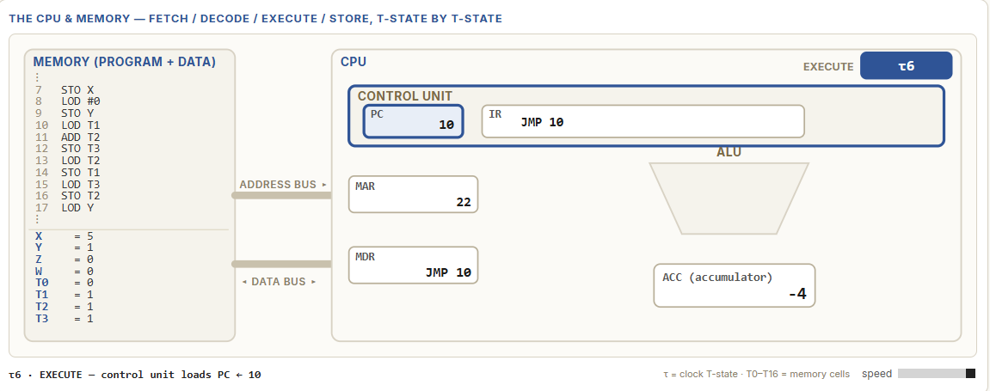
Image 6.2. After pass 2: T1 = 1, T2 = 2, T3 = 2, Y = 2
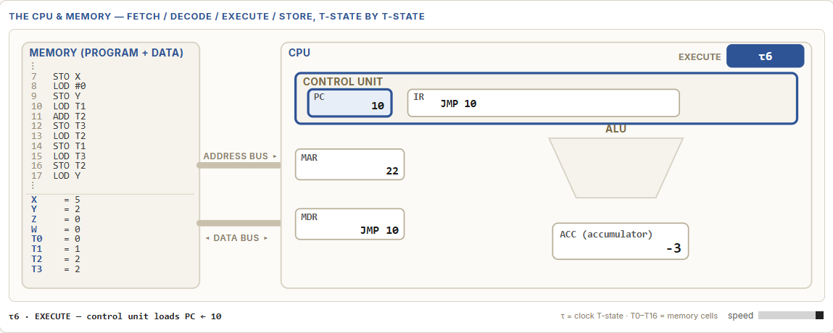

Image 6.3. After pass 3: T1 = 2, T2 = 3, T3 = 3, Y = 3
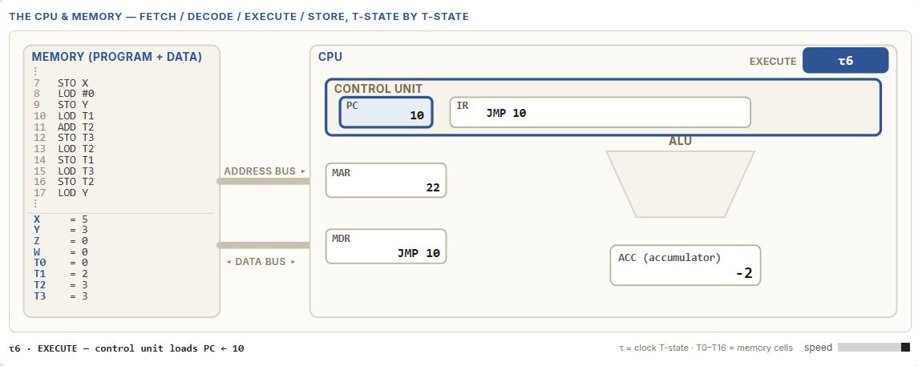
Image 6.4. After pass 4: T1 = 3, T2 = 5, T3 = 5, Y = 4
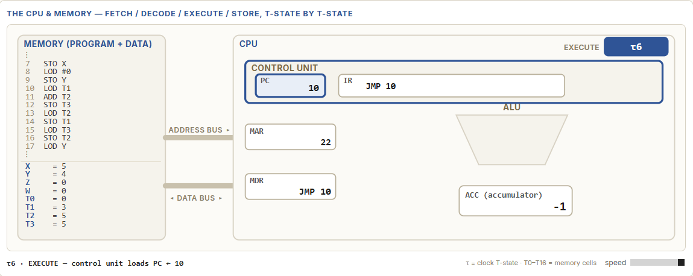

Image 6.5. After pass 5: T1 = 5, T2 = 8, T3 = 8, Y = 5. The program halts.
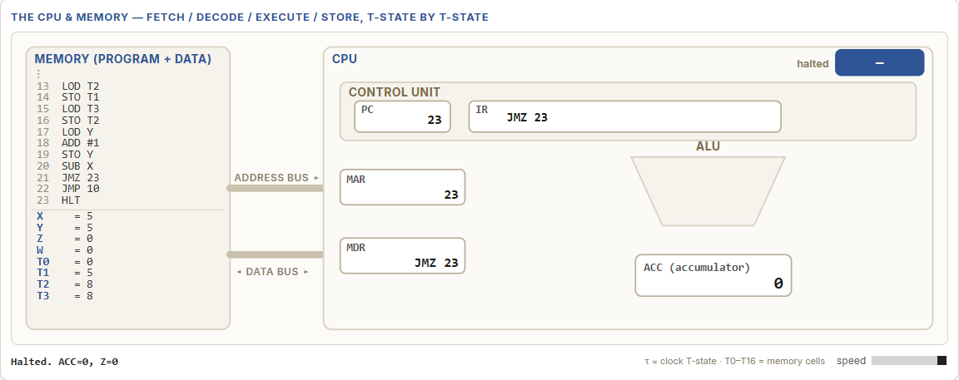

Individual self-evaluation
Team member | Criterion | Score (1 to 5) | Personal reason and evidence
Nikita | Originality | 3 | We used a well-known sequence, but we had to turn its rule into a VNMSim loop.
Nikita | Complexity | 3 | The code is short. I spent most time understanding how the registers move and which address JMP uses.
Nikita | Solution quality | 5 | The first four saved states matched our expected values. The program still needs a stop condition.
Nikita | LLM co-development skills | 4 | AI helped me understand the loop and JMP 10. I checked the target and values in VNMSim; the counter suggestion is untested.
Kevin | Originality | 3 | The sequence itself is familiar, but translating it into VNMSim instructions was part of our work.
Kevin | Complexity | 4 | For me, the tricky part was following the order of LOD and STO so the program used the right terms.
Kevin | Solution quality | 4 | The screenshots show the expected register changes. The program works as a loop, although it does not stop automatically.
Kevin | LLM co-development skills | 3 | AI explanations helped me follow the code. I still needed to compare them with the listing and simulator results.
Illia | Originality | 3 | Fibonacci is a standard problem; our work was implementing it with three registers and a jump in VNMSim.
Illia | Complexity | 3 | The program is not long, but checking each pass took care because T3 changes every time around the loop.
Illia | Solution quality | 4 | I recorded four passes and checked them against the expected values. We did not capture pass five, and we stop the loop manually.
Illia | LLM co-development skills | 4 | AI gave us useful explanations, but I checked the jump and first four values in VNMSim.
Team reflection on AI use
AI effectiveness rating (1 to 5) and reason: 4. AI helped us understand the rolling-register idea and JMP 10. We still checked the address and register values in VNMSim.
Helpful advice and how we checked it in VNMSim: AI explained that JMP 10 returns to LOD T1. We checked the address in the listing and compared the register states with the Fibonacci rule.
Limited or unused advice: The AI suggested removing the Y value and only relying on X value for loop amounts and suggested removing T3 value and instead used other variables that already exist in the memory.
What we would change next time: Implement a simpler code by removing excess values that the AI pointed out.
Working with AI compared with working alone: AI made it easier to discuss the idea and understand some instructions. We still had to check the explanations in VNMSim.
Appendix A: Selected excerpts from our AI discussion
These shortened excerpts come from our saved chat transcript. They show how we used AI to discuss the idea, check the register pattern, and understand the loop instruction. We entered and checked the simple loop in VNMSim ourselves.
Stage | Chat excerpt and what our team did
Planning | Our prompt: "We are working on an exercise, and our idea is to generate Fibonacci numbers in VNMSim using a loop." AI suggested checking jump support, deciding whether to show one term or a sequence, and considering the simulator number range. We chose a rolling-register Fibonacci program.
Checking the algorithm | We explained how T1 and T2 are added into T3, then shifted for the next pass. AI confirmed the rolling-window pattern and noted that T3 is overwritten and JMP keeps the loop running. We used the register values as checkpoints.
Understanding JMP | We asked for one instruction to return to address 10 without changing the program into a counter version. AI replied: "Add JMP 10 at address 22. It unconditionally sends execution back to address 10." We entered the instruction and checked the first four passes in VNMSim.
Evaluating another idea | We asked the LLM: “What else could be implemented in the code?”, and the AI gave us ideas on possibly simplifying the code by removing excess values, like Y and T3, and use values that already exist in the memory, or rather not even use them at all, since the loop counter can be used without Y. We decided to not simplify the code.

